**Classes and Objects**

In visual basic, Classes and Objects are interrelated. The class in visual basic is nothing but a collection of various data members (fields, properties, etc.) and member functions. The object in visual basic is an instance of a class to access the defined properties and methods.

Visual Basic Class

In visual basic, Class is a data structure and it will combine the various types of data members such as fields, properties, member functions and events into a single unit.

Create Class in Visual Basic

In visual basic, classes can be created by using Class keyword. Following is the declaration of class in a visual basic programming language.

Public Class users

' Properties, Methods, Events, etc.

End Class

If you observe the above syntax, we defined the class “users” using Class keyword with public access modifier. Here, the public access specifier will allow the users to create an object for "users" class and in the class body, we can create the required fields, properties, methods and events to use it in our applications.

Now, we will see how to create a class in visual basic programming language with example.

Visual Basic Class Example

Following is the example of creating a class in visual basic programming language with various data members and member functions.

Public Class Users

Public id As Integer = 0

Public name As String = String. Empty

Public Sub New()

' Constructor Statements

End Sub

Public Sub GetUserDetails(ByVal uid As Integer, ByVal uname As String)

id = uid

uname = name

Console.WriteLine("Id: {0}, Name: {1}", id, name)

End Sub

Public Property Designation As Integer

Public Property Location As String

End Class

If we observe the above visual basic class example, we defined the “Users” class with a various data members and member functions based on our requirements.

Following is the detailed description of various data members which we used in the above visual basic class example.

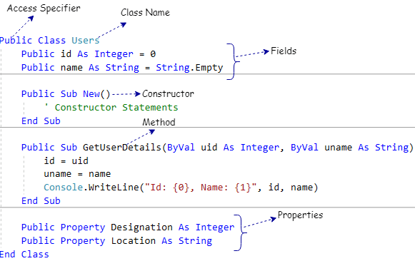

If you observe the above image, we used various data members like access modifiers, fields, properties, methods, constructors, etc. in our visual basic class based on our requirements.

**Visual Basic Class Members**

Class can contain multiple data members in a visual basic programming language. The following table lists a different type of data members that can be used in visual basic classes.

Member Description

Fields Variables of the class

Methods Computations and actions that can be performed by the class

Properties Actions associated with reading and writing named properties of the class

Events Notifications that can be generated by the class

Constructors Actions required to initialize instances of the class or the class itself

Operators Conversions and expression operators supported by the class

Constants Constant values associated with the class

Indexers Actions associated with indexing instances of the class like an array

Finalizers Actions to perform before instances of the class are permanently discarded

Types Nested types declared by the class

We can use required data members while creating the class in visual basic programming language based on our requirements.

**Visual Basic Object**

In visual basic, Object is an instance of a Class and that can be used to access the data members and member functions of a class.

**Creating Objects in Visual Basic**

Generally, we can say that objects are the concrete entities of classes. In visual basic, we can create objects by using a New keyword followed by the name of the class like as shown below.

Dim user As Users = New Users()

If you observe the above example, we created an instance (user) for the class (Users) which we created in the previous section. Now the instance “user” is a reference to an object that is based on the Users. By using the object name “user” we can access all the data members and member functions of Users class.

**Visual Basic Objects Example**

Following is the example of creating objects in visual basic programming language.

Module Module1

Sub Main()

Dim user As Users = New Users("Kishore Kumar", 40)

user.GetUserDetails()

Console.WriteLine("Press Enter Key to Exit..")

Console.ReadLine()

End Sub

Public Class Users

Public Property UName As String

Public Property UAge As Integer

Public Sub New(ByVal name As String, ByVal age As Integer)

UName = name

UAge = age

End Sub

Public Sub GetUserDetails()

Console.WriteLine("Name: {0}, Age: {1}", UName, UAge)

End Sub

End Class

End Module

Visual Basic Classes and Objects Example Result

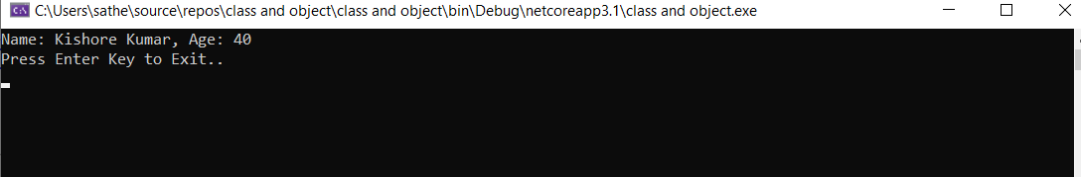

This is how we can create and use the classes and objects in visual basic applications based on our requirements.